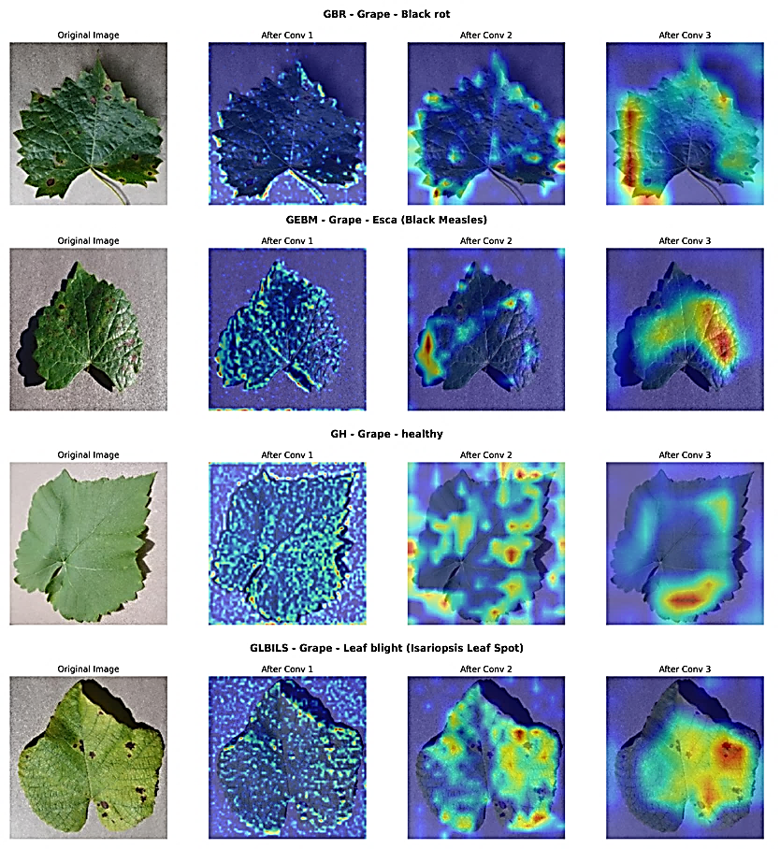
Fig. 4.3 Feature Extraction Visualization of Grape Leaves

